**A Smart Crop Recommendation Application for Enhanced Agricultural Productivity**

Rutuja Santosh Thube

(20/07/2024)

*Abstract*

The Crop Recommendation System is an innovative web-based platform designed to assist farmers in making informed decisions about crop selection. The Integrated Crop Recommendation System is a comprehensive digital tool designed to revolutionize agricultural decision-making by providing farmers with data-driven insights. By analysing soil nutrient composition (N-P-K ratios) and local climatic conditions (temperature, humidity), the system recommends the most suitable crops for specific conditions, optimizing yields and sustainability. Additionally, it features a plant disease detection module that identifies crop diseases through image analysis, offering timely diagnosis and effective treatment suggestions to minimize crop losses. Furthermore, the system delivers precise fertilizer recommendations by assessing soil nutrient content and crop requirements, ensuring balanced and efficient nutrient management. This integrated approach not only enhances crop productivity and health but also promotes sustainable farming practices, ultimately boosting the economic viability of farming operations.

1. **Problem Statement**

The agriculture sector faces persistent challenges that impede optimal productivity and sustainability. Farmers often lack precise information for making informed decisions regarding crop selection, disease management, and nutrient optimization. Traditional methods, relying on anecdotal knowledge and historical practices, frequently result in suboptimal yields, increased vulnerability to plant diseases, and inefficient fertilizer use. To address these issues, we propose the development of an Integrated Crop Recommendation System that provides comprehensive support to farmers. This system will leverage advanced machine learning and real-time data analysis to recommend suitable crops based on soil nutrient composition (N-P-K ratios) and local climatic conditions (temperature, humidity). Additionally, it will enable farmers to diagnose plant diseases through image uploads, providing accurate disease identification and effective treatment suggestions. Furthermore, the system will offer tailored fertilizer recommendations by analysing soil nutrient content and crop requirements, ensuring balanced and efficient nutrient management. By integrating these functionalities, the proposed system aims to enhance crop yields, reduce losses due to disease, and promote sustainable agricultural practices, ultimately improving the economic viability and productivity of farming operations.

### 1.1 Benefits of the Crop Recommendation System

1. Enhanced Yield: By recommending the best crops suited for specific conditions, farmers can significantly improve their agricultural output.
2. Disease Management: Early detection of plant diseases allows for timely interventions, minimizing crop loss.
3. Fertilizer Optimization: Suggesting tailored fertilizers can reduce waste, lower costs, and enhance soil health, promoting sustainable practices.
4. Data-Driven Decision Making: Leveraging AI and machine learning empowers farmers with evidence-based insights, leading to better decision-making.
5. Resource Efficiency: By optimizing crop choice and fertilizer use, farmers can manage resources better, contributing positively to environmental sustainability.
6. **Market Need Assessment**
   1. **Market Overview**

The agricultural technology (AgTech) market is experiencing rapid growth due to the increasing need for efficient farming practices and the adoption of digital solutions. The Crop Recommendation System is positioned within this market, catering to farmers, agronomists, and agricultural organizations looking to enhance crop yields and sustainability through data-driven insights.

* 1. **Market Segmentation**
* Geographic Segmentation: The demand for crop recommendation systems varies by region based on agricultural practices, technological adoption, and climate conditions. Developing regions such as Asia-Pacific and Africa are witnessing increased interest due to the need for improved agricultural productivity, while developed regions like North America and Europe have a mature market with high technology adoption.
* Customer Segmentation:
  1. Small and Medium-Sized Farms: These farmers often lack access to expert advice and rely on affordable, user-friendly solutions to improve their crop management.
  2. Large Agricultural Enterprises: Larger operations may seek advanced, integrated systems with robust data analytics and customized recommendations.
  3. Agricultural Extension Services: Government and non-governmental organizations providing support to farmers can use such systems to offer tailored advice and enhance outreach programs.
* Key Market Trends

1. Digital Transformation in Agriculture: The integration of digital tools and data analytics is transforming traditional farming practices. There is a growing emphasis on precision agriculture, which requires accurate recommendations for crop selection, disease management, and fertilizer use.
2. Sustainability and Environmental Concerns: There is increasing awareness of sustainable farming practices. Systems that optimize fertilizer use and manage crop diseases can contribute to environmental sustainability by reducing chemical use and minimizing soil degradation.
3. IoT and Data Integration: The use of Internet of Things (IoT) devices and sensors is becoming more common, providing real-time data on soil conditions, weather, and crop health. A recommendation system that integrates with these technologies can offer more accurate and timely advice.
4. **Indirect Competitors:** Traditional agricultural extension services and consultancy firms may also offer crop recommendations and advice, though they may lack the technological integration of a digital system.

The market for Crop Recommendation Systems is expanding due to the increasing need for efficient and sustainable agricultural practices. By addressing key customer needs, leveraging technological advancements, and navigating the competitive landscape, there are significant opportunities for growth and impact within this sector.

1. **Target Specifications**
   1. **Core Functionality**

**1. Crop Recommendation**

The primary function of a Crop Recommendation System is to analyse various parameters and suggest the best crops suited for a specific piece of land. Key factors influencing this process include:

* Soil Type and Quality: Analysing the pH level, nutrient content, and moisture retention capacity of the soil.
* Climate Conditions: Evaluating local weather patterns, average rainfall, temperature ranges, and seasonal changes.
* Geographical Location: Considering regional agricultural practices, crop yield histories, and market demand.

By inputting these variables, farmers receive recommendations for crops that are more likely to flourish in their specific environments, thereby maximizing yield and profitability.

**2. Disease Diagnosis**

Plant diseases can devastate crops and significantly affect a farmer's income. The CRS addresses this issue through:

* Image Recognition Technology: Farmers can upload images of their plants, and the system employs machine learning algorithms to analyse the images and identify any visible symptoms of diseases.
* Diagnostic Algorithms: The system utilizes a database of plant diseases to match symptoms with potential health issues, providing immediate insights about the condition of the crops.

**3. Fertilizer Suggestions**

To further enhance crop growth and health, the CRS provides tailored fertilizer recommendations based on:

* Nutrient Deficiencies: Testing the soil can reveal essential nutrients that may be lacking, guiding fertilizer selection intended to bolster soil fertility.
* Crop Needs: Different crops require different nutrient profiles at various growth stages, which the CRS accounts for in its suggestions.

By connecting crop needs with soil health, farmers can make informed decisions about how and when to fertilize.

* 1. **Design Overview**
  2. User-Friendly Interface**:** The design of the Crop Recommendation System prioritizes user experience. A simple and intuitive interface allows farmers, even those with minimal technical skills, to navigate the application easily. Key design features include:
* Dashboard: A comprehensive dashboard that provides an overview of crop recommendations, disease alerts, and fertilizer suggestions.
* Input Fields**:** Clear fields for entering soil and weather parameters, along with easy image upload options for disease diagnosis.
* Visual Aids: Infographics and charts that represent data trends and predictions make it easier for users to comprehend complex information.
  1. Integration of Machine Learning**:** The backbone of any effective CRS lies in its ability to utilize machine learning algorithms. By continuously learning from user inputs and outcomes, the system becomes more accurate over time. Innovative algorithms enable the CRS to process a vast amount of agricultural data, enhancing its predictive capabilities.
  2. Mobile Accessibility: To maximize reach, the CRS should ideally be available as a mobile application. This allows farmers in remote areas to access valuable information directly from their smartphones, breaking down barriers to technology in agriculture.

**3.3 Performance Requirements**

## Accuracy

### Crop Recommendation: The primary function of the system is to recommend suitable crops based on various parameters such as soil type, climate, and previous crop yield. The accuracy of these recommendations is crucial for maximizing agricultural output. The system should achieve at least 90% accuracy in predicting the most suitable crops for a given set of conditions.

### Disease Diagnosis: The system should employ machine learning models that can accurately identify plant diseases based on image data and other symptoms. A minimum accuracy rate of 85% in disease detection is essential to prevent crop loss and ensure timely intervention.

### Fertilizer Suggestions: Fertilizer recommendations should be based on soil nutrient levels and specific crop requirements. The system must ensure at least 90% accuracy in suggesting the appropriate fertilizers and their application rates to enhance crop growth.

## Response Time : In agricultural environments, timely recommendations can significantly affect crop yields. The system should be able to process inputs and deliver recommendations within a short time frame ideally under 3 seconds for real-time applications. This quick response time is vital for farmers who may need to make immediate decisions regarding planting and crop management.

## Usability : The system must feature an intuitive user interface that is easy to navigate, even for users with limited technical expertise. Clear visualizations and straightforward workflows can help farmers swiftly interpret recommendations without confusion.

1. Scalability: As agricultural practices evolve and data sources increase, the system should be built to accommodate future growth. It must easily scale to handle larger datasets, integrate new machine learning models, and adapt to diverse agricultural regions and practices.
2. Security : Given the sensitivity of agricultural data, the system must employ robust security measures to protect user information and ensure data privacy. Secure data storage, encryption, and regular audits are essential components of a secure architecture.

**4. External Search**

A Crop Recommendation System is a technological platform designed to assist farmers in making informed decisions about crop selection, disease management, and soil health. The primary objective is to maximize yield while minimizing the resource expenditure associated with farming. These systems commonly integrate diverse datasets, including climate conditions, soil characteristics, and crop behavior, to deliver tailored recommendations.

**4.1 Benchmarking**

## **1.** Importance of Benchmarking in Crop Recommendation Systems

Benchmarking serves as a crucial process for evaluating the performance and effectiveness of CRS. It involves comparing systems and methodologies against recognized standards to identify areas for improvement and ensure consistent performance. Here are some reasons why benchmarking is important:

* **Quality Improvement:** Continuous benchmarking helps refine algorithms used for crop recommendations, disease diagnosis, and fertilizer suggestions, leading to improved accuracy.
* **Performance Assessment**: Systems can be assessed across various metrics, including response time, accuracy of recommendations, and user satisfaction, facilitating informed improvements.
* **Standardization:** Benchmarking promotes adherence to industry standards, which can help establish best practices for CRS development and deployment.
* **Innovation Drive**: By evaluating against competitors, developers can identify gaps in their systems and innovate features that enhance user experience and functionality.

## **2**. Methodologies for Benchmarking CRS

Benchmarking a Crop Recommendation System can involve several methodologies, which can be broadly categorized into quantitative and qualitative assessments:

### 1. Data-Driven Evaluation

* **Accuracy Testing**: Evaluate the accuracy of crop recommendations by comparing system suggestions against actual crop performance in various regions.
* **Disease Detection Validation**: Use datasets of diseased and healthy plant images for testing the performance of disease detection algorithms, such as convolutional neural networks (CNNs).
* **Fertilizer Optimisation Metrics**: Analyse how well the system's fertilizer recommendations translate into increased yield and improved soil health through controlled field trials.

### 2. User Experience Assessment

* **Surveys and Feedback**: Conduct surveys among users to gauge satisfaction levels and usability concerns. This qualitative data can highlight strengths and weaknesses in the system.
* **Case Studies**: Document real-world examples where the CRS provided significant benefits to farmers, detailing productivity increases and cost savings.

### 3. Comparative Analysis

* **Competitor Benchmarking**: Compare performance metrics, features, and user acceptance of the CRS against other systems available in the market.
* **Cross-Disciplinary Studies**: Investigate collaborations between agricultural experts and data scientists to enhance the CRS capabilities in various agricultural contexts.

## **3**. Challenges in Benchmarking CRS

While the importance of benchmarking is clear, there are challenges associated with it:

1. **Data Availability**: High-quality and diverse datasets are essential for model training and validation but may not always be readily available.
2. **Dynamic Agricultural Conditions**: Agricultural environments are ever-changing due to climate variability, making it challenging to establish a static benchmark.
3. **Interdisciplinary Knowledge Requirements**: Effective benchmarking often requires expertise in agriculture, computer science, and data analytics, making collaboration crucial.

**5. Constraints and Regulations**

## 1. **Data Privacy and Security**

### Constraints : One of the foremost constraints in developing a Crop Recommendation System is ensuring data privacy and security. As CRS relies heavily on data collection from farms, including geographic location, soil type, and crop history, the protection of this sensitive information is paramount. Unauthorized access or misuse of data could lead to competitive disadvantages or even financial loss for farmers.

### Regulations : In many countries, laws such as the General Data Protection Regulation (GDPR) in Europe impose strict requirements regarding data collection, processing, and storage. Developers of CRS must ensure compliance with these regulations, integrating robust security measures to protect user data and provide clear consent mechanisms.

## 2. **Agronomic Standards and Recommendations**

### Constraints : Crop recommendations must be scientifically valid and suited to local agricultural conditions. This includes factors such as climate, soil chemistry, and local pest dynamics. A one-size-fits-all recommendation can lead to poor outcomes, including crop failure, reduced yields, or environmental harm.

### Regulations : Regulatory bodies often set forth guidelines regarding what constitutes safe and effective agricultural practices. In many regions, there might be standards for Integrated Pest Management (IPM), organic farming methods, or nutrient management that must be integrated into the recommendations provided by a CRS. Compliance with these standards is crucial to ensure that recommendations protect not only the farmer's investments but also the surrounding ecosystem.

## 3. **Environmental Impact**

### Constraints : The recommendations generated by a CRS could have significant implications for the environment. Misguided crop selections or improper fertilizer use could lead to soil degradation, reduced biodiversity, and contamination of water sources through runoff.

### Regulations : Various environmental regulations, such as the Clean Water Act in the United States or similar directives globally, mandate that agricultural systems adhere to practices that protect natural resources. A CRS must incorporate environmental impact assessments and provide recommendations that minimize adverse effects on the ecosystem.

## 4. **Socio-Economic Factors**

### Constraints : The socio-economic status of farmers, including their access to resources, knowledge levels, and market connections, can limit the effectiveness of a Crop Recommendation System. In regions where farmers lack access to necessary inputs (such as high-quality seeds or fertilizers) or lack technical knowledge, even the best recommendations may be impractical.

### Regulations : Policies that govern access to agricultural inputs, such as subsidies or loans, can vary widely. A successful CRS should consider these socio-economic factors and align its recommendations with available resources and support programs, ensuring that farmers can act upon the guidance provided.

## 5. **Technology Adaptation and Accessibility**

### Constraints : The effectiveness of a Crop Recommendation System can be hindered by technological barriers. In many rural areas, access to reliable internet and awareness of digital tools may pose significant obstacles to widespread adoption.

### Regulations : Governments may implement broad strategies to improve digital infrastructure in rural areas. Regulatory frameworks might exist to facilitate technology transfer or support initiatives aimed at increasing digital literacy among farmers.

**6. Monetization Strategies for Crop Recommendation App**

In today's rapidly evolving agricultural landscape, technology plays a critical role in improving productivity and sustainability. One such innovation is the crop recommendation app, designed to assist farmers in selecting the right crops, diagnosing plant diseases, and providing fertilizer suggestions tailored to their specific needs. While these apps can significantly benefit users, it is crucial to develop effective monetization strategies to ensure their sustainability and profitability. Here are several approaches to consider for monetizing a crop recommendation app.

## **1. Freemium Model**

The freemium model is a popular strategy in the app industry that extends basic features for free while offering premium features for a fee. For a crop recommendation app:

* **Free Tier:** Offer essential functionalities, such as basic crop recommendations and disease identification, to attract a wide user base.
* **Premium Tier:** Introduce advanced features, including detailed fertilizer suggestions, in-depth analytics, expert consultations, or real-time weather forecasts for a monthly or annual subscription fee.

## **2. In-App Purchases**

In-app purchases can complement a freemium model by enabling users to buy specific features or additional content directly from the app.

* **Data Insights and Reports:** Offer specialized reports or analytics allowing farmers to understand market trends, soil health data, or crop performance forecasts.
* **Expert Consultations:** Provide an option for users to consult agronomists or crop specialists at a fee for personalized recommendations or troubleshooting advice.

## **3. Advertisements and Affiliate Marketing**

Incorporating advertisements or engaging in affiliate marketing can be an effective monetization strategy, especially if the app has a robust user base.

* **Advertisements:** Partner with agricultural brands, fertilizer companies, or agricultural equipment manufacturers to display relevant ads within the app. Consider using Google AdMob or similar platforms for targeted ad placement.
* **Affiliate Marketing:** Recommend agricultural products (seeds, fertilizers, pesticides) through affiliate ties with suppliers, earning a commission for each sale generated from the app.

## **4. Subscription-Based Models**

Consider a subscription model if the app provides ongoing value. Users can pay a recurring fee for continuous access to enhanced features.

* **Membership Plans:** Develop tiered plans based on the size of the farm, types of crops, or specific agricultural needs. Higher-tier plans could offer additional services, such as personalized crop calendars and direct access to agronomists.
* **Seasonal Subscriptions:** Provide options for seasonal subscriptions, aligning with planting and harvesting cycles, allowing farmers to subscribe only when they need specific insights.

## **5. Partnerships and Collaborations**

Forming partnerships with agricultural organizations, research institutions, or government bodies can not only enhance the app's credibility but also create additional revenue opportunities.

* **Research Grants:** Take advantage of grants from agricultural research organizations for data collection or analysis initiatives.
* **Corporate Sponsorships:** Allow agricultural companies to sponsor certain features within the app, such as crop education modules or disease diagnostic tools.

**7. Final Product Prototype**

The Crop Recommendation System is designed to assist farmers, agronomists, and agricultural professionals by providing tailored crop recommendations, diagnosing plant diseases, and suggesting appropriate fertilizers. The system leverages data analytics, machine learning, and user-friendly interfaces to deliver actionable insights.

**1.Key Features**

#### **1.1 Crop Recommendation Engine**

* **User Input Form:** Allows users to input data such as soil type, location, weather conditions, and historical crop performance.
* **Recommendation Algorithm:** Analyses input data and suggests the most suitable crops for planting, including seasonal recommendations.
* **Results Display:** Provides a list of recommended crops along with details on expected yield, optimal planting times, and care instructions.

#### **1.2 Disease Diagnosis System**

* **Image Upload:** Users can upload images of plants showing symptoms of diseases.
* **Symptom Input:** Option to manually input symptoms if images are not available.
* **Diagnosis Algorithm:** Uses machine learning to analyse images and symptoms to diagnose plant diseases.
* **Treatment Recommendations:** Provides suggested treatments, preventative measures, and remedies for identified diseases.

#### **1.3 Fertilizer Suggestion Module**

* **Soil Analysis Input:** Users can input soil test results or use built-in soil sensor integrations.
* **Fertilizer Database:** Contains detailed information on various fertilizers, including their composition and application guidelines.
* **Recommendation Engine:** Suggests fertilizers based on crop requirements, soil conditions, and growth stages.
* **Application Instructions:** Provides guidance on how and when to apply the recommended fertilizers.

**2.User Interface Design**

#### **2.1 Dashboard**

* **Central Hub:** Displays an overview of crop recommendations, disease diagnoses, and fertilizer suggestions.
* **Quick Access:** Easy access to different modules via a sidebar or top navigation menu.
* **Notifications:** Alerts for critical updates, such as disease outbreaks or optimal planting times.

#### **2.2 Input Forms**

* **Intuitive Design:** Simple, step-by-step forms for entering data related to soil, weather, plant symptoms, etc.
* **Validation:** Real-time validation to ensure data accuracy and completeness.

#### **2.3 Visualization Tools**

* **Graphs and Charts:** Visual representations of data, such as soil nutrient levels, crop performance trends, and fertilizer application schedules.
* **Interactive Maps:** Geographic information system (GIS) maps showing recommended crops for different regions.

#### **2.4 Reports and Analytics**

* **Detailed Reports:** Generates comprehensive reports on crop recommendations, disease management, and fertilizer use.
* **Performance Tracking:** Monitors and displays the effectiveness of recommendations and user outcomes over time.

**8. Schematic Diagram**

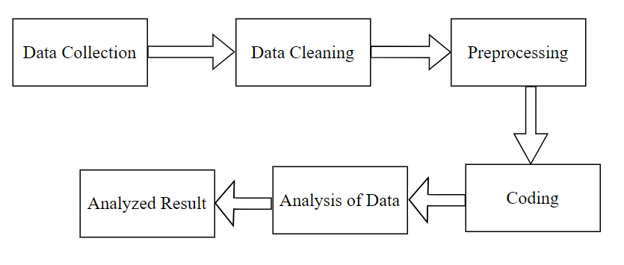

**8.1 Flowchart of the Steps**

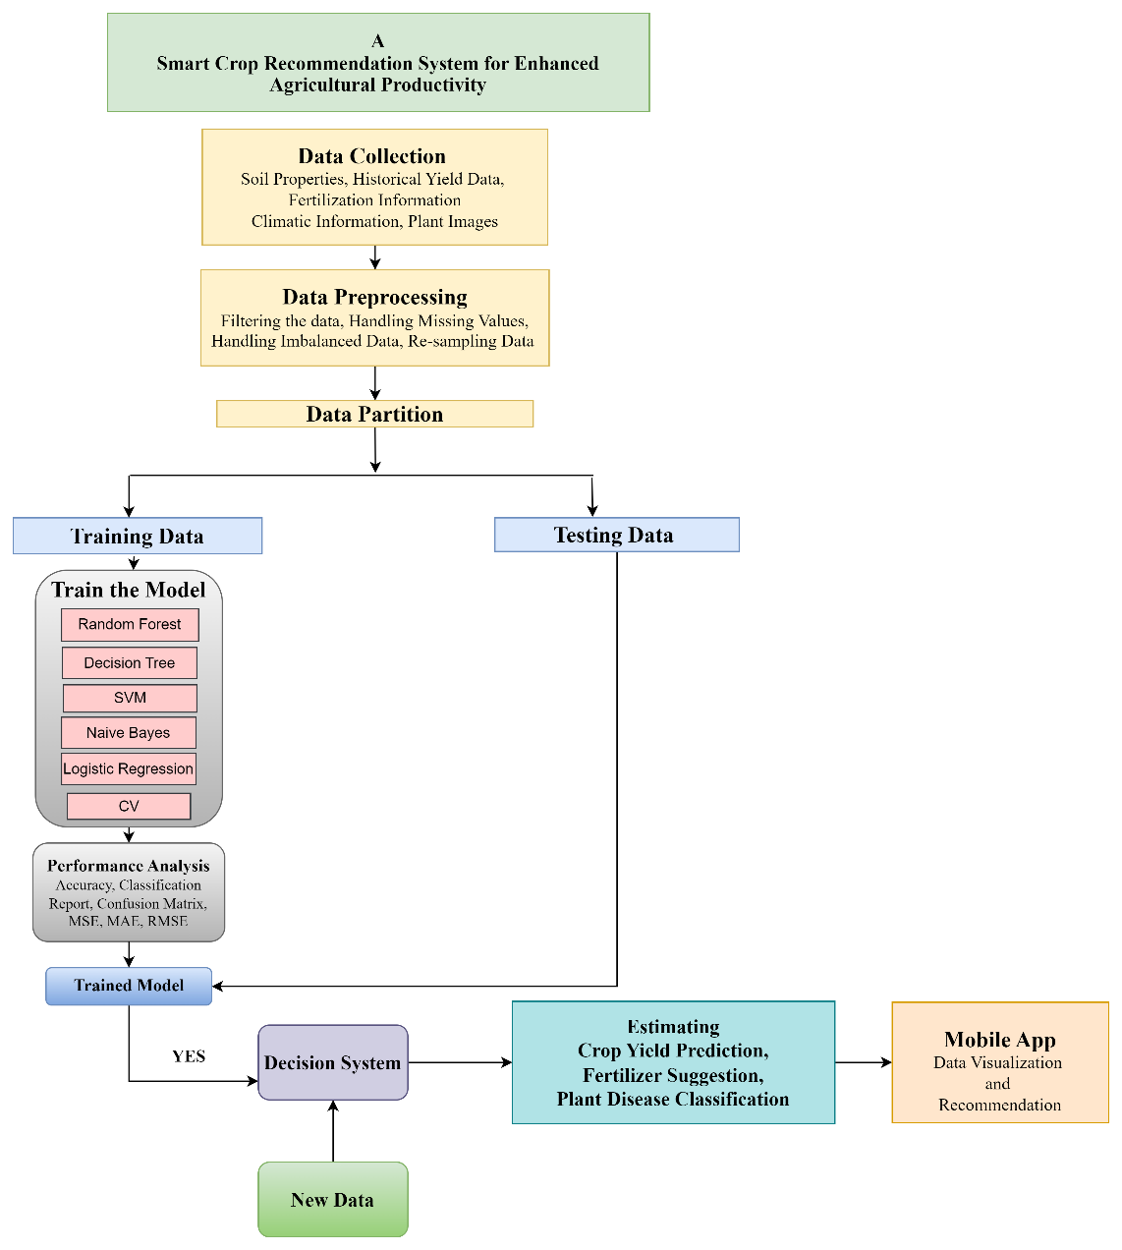

**8.2 Schematic Diagram of the Model**

* **Power Bi Dashboard for Crop Yield Prediction System :**

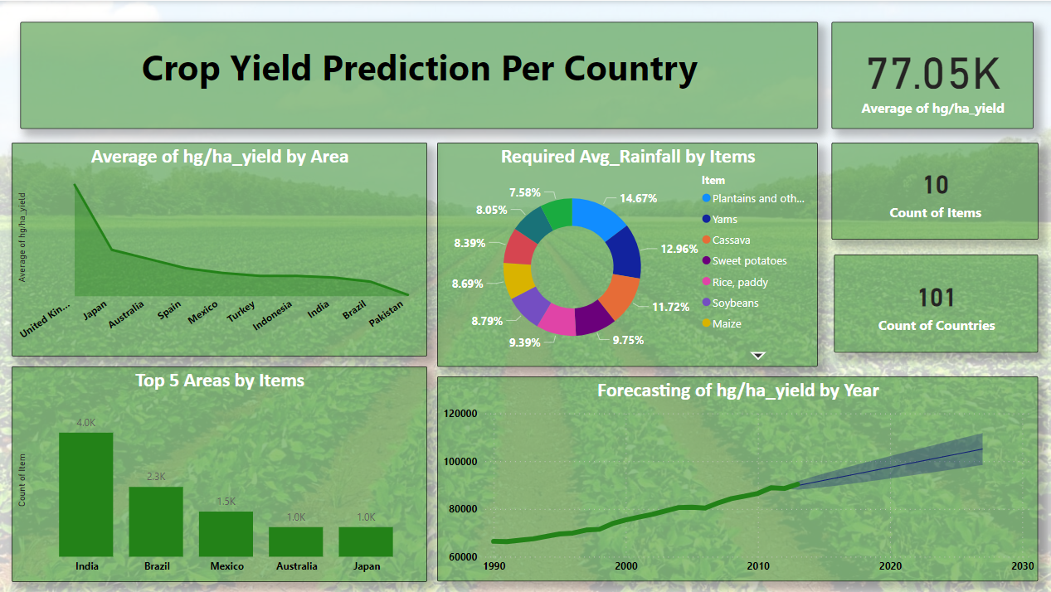

**Explanation of the Crop Yield Prediction System Dashboard**

This Power BI dashboard provides insights into a crop yield prediction system. Each visual and metric displayed is designed to give a comprehensive overview of the dataset used for predicting crop yield. Here’s a detailed explanation of each component in the dashboard:

**Key Insights :**

* **Overall Yield:** The average yield across all countries is 77.05K hg/ha.
* **Top Yielding Countries:** The highest yield is observed in Japan, followed by Australia and Spain.
* **Top 5 Areas by Items:** India has the highest count of items, followed by Brazil and Mexico.
* **Rainfall:** The required average rainfall for each crop varies. Maize requires the highest rainfall (9.75%), followed by rice, paddy (9.39%).
* **Yield Trend:** The forecasting of hg/ha_yield by year shows a steady increase from 1990 to 2030.

This dashboard can be a valuable tool for decision-making in agriculture. By understanding the trends and insights, stakeholders can implement effective measures to enhance crop production and ensure food security.

**9. Product details**

**9.1 How it is operated?**

1. **Data Collection and Analysis**:The foundational step in any CRS involves collecting extensive data regarding soil conditions, climatic factors, crop yield history, and agricultural practices. Data sources may include satellite imagery, weather forecasts, soil testing results, and existing agricultural databases. Advanced data analytics and machine learning algorithms are then employed to interpret this data and identify patterns that inform crop selection.
2. **Model Training:** Creates three different prediction model for various crops by using historical data and this train using machine learning and deep learning algorithms.
3. **Crop Recommendation**: Using the data gathered, the CRS can recommend the most suitable crops for a specific region based on various parameters such as climate, soil type, and nutrient availability. For instance, a system might analyse the soil's pH, moisture content, and nutrient levels to recommend crops that would thrive under current conditions such as rice in flooded areas or drought-resistant millet in arid regions.
4. **Disease Prediction and Management**:By incorporating machine learning algorithms, systems can analyse environmental factors and disease symptoms, allowing them to identify vulnerabilities in crops and recommend timely interventions. This can include the use of biological controls, fungicides, or even modified planting schedules.
5. **Fertilizer Recommendations**: Another critical aspect of crop management is ensuring that plants receive the appropriate nutrients. CRS often provides detailed fertilizer recommendations based on soil nutrient levels.
6. **Mobile App**: To effectively communicate these recommendations to farmers, a user-friendly interface often delivered through mobile applications or web platforms is essential. This interface should allow farmers to input data about their fields, view personalized recommendations, and even keep track of their crops’ health over time. Educational resources might also be included to help farmers understand the science behind the recommendations and encourage best practices.

**9**.**2 Data Sources**

* **Historical Yield Data**: Information from prior harvests is crucial in evaluating crop performance and making recommendations based on past successes or failures.
* **Climate Databases**: Global databases, such as the World Meteorological Organization (WMO) and climate data services from organizations like NASA, offer valuable long-term climate insights.
* **Soil Testing Laboratories**: Soil samples analysed in laboratories provide essential data on pH levels, nutrient content (NPK), organic matter, and soil texture.
* **Meteorological Stations**: National and regional weather stations provide historical and real-time data on temperature, rainfall, humidity, and wind patterns.

**9.3 Algorithms, frameworks, software**

1. **Software and Tools :**

* Programming Language :Python
* IDE :Jupyter Notebook, VSCode
* Web Application :
* **Flask :** Flask is a web framework that allows developers to build lightweight web applications quickly and easily with Flask Libraries.
* Libraries :
* Model Training and Evaluation : Scikit-learn (for machine learning algorithms)
* Data Handling and Analysis **:** Pandas, NumPy
* Visualization : Matplotlib, Seaborn, PowerBI

1. **Hardware :**

* System Configuration :The project will implement on a system with the following configuration:
* Processor : 13th Gen Intel(R) Core(TM) i5-13420H 2.10 GHz
* RAM : 16 GB
* OS : Windows 11

1. **Machine Learning Algorithms**

The following machine learning algorithms were implemented using sklearn:

* **Linear Regression :** It attempts to establish a linear relationship between input features (independent variables) and a continuous output variable (dependent variable).
* **Lasso Regression :** (Least Absolute Shrinkage and Selection Operator) This technique not only fits the model but also penalizes large coefficients, essentially shrinking some of them to zero.
* **Ridge Regression :** This means that it penalizes the square of the coefficients instead of the absolute values, allowing all coefficients to remain non-zero.
* **Decision Tree :** Decision Trees are non-linear models that work by recursively splitting the data into branches based on feature values to make predictions.
* **K- Nearest Neighbors (KNN) Regression :** KNN is a non-parametric method that predicts the output for a given sample by averaging the outputs of the 'k' nearest neighbors in the feature space.
* **Classification Algorithms :** A program learns from the given dataset or observations and then classifies new observation into a number of classes or groups.
* **Time-Series Forecasting :** Time series analysis for trend forecasting is a powerful method used to predict future values based on previously observed values.
* **Autoregressive Integrated Moving Average (ARIMA)** : A popular method that combines autoregression (AR), differencing (I), and moving average (MA) components.
* **Computer Vision** : It enables computers to analyse images or video data, unlocking a multitude of applications across industries, from autonomous vehicles to facial recognition systems.
* **PowerBI :** Power BI is a business analytics tool developed by Microsoft that allows users to visualize data and share insights across their organization or embed them in an app or website.

**10. Motivation**

* Farming is one of the major sectors that influences a country’s economic growth.
* In country like India, majority of the population is dependent on agriculture for their livelihood. Many new technologies, such as Machine Learning and Deep Learning, are being implemented into agriculture so that it is easier for farmers to grow and maximize their yield.
* In this project, I will present a website in which the following applications are implemented; Crop recommendation, Fertilizer recommendation and Plant disease prediction, respectively.
  + In the crop recommendation application, the user can provide the soil data from their side and the application will predict which crop should the user grow.
  + For the fertilizer recommendation application, the user can input the soil data and the type of crop they are growing, and the application will predict what the soil lacks or has excess of and will recommend improvements.
  + For the last application, that is the plant disease prediction application, the user can input an image of a diseased plant leaf, and the application will predict what disease it is and will also give a little background about the disease and suggestions to cure it.

**11.Conclusion**

In conclusion, a comprehensive crop recommendation system that integrates crop selection, disease identification, and fertilizer suggestions offers a powerful tool for modern agriculture. By supporting farmers with data-driven insights and practical recommendations, such systems not only enhance productivity but also contribute to sustainable agricultural practices. As we look towards the future of farming, the implementation of such technologies will play a pivotal role in overcoming challenges, ensuring resiliency, and achieving a more sustainable agricultural landscape for generations to come.

**12. Program Code**

As I did not completed all the parts. I have only made Crop Yield Prediction System from the entire application. Apart from that it will suggest the fertilizers and using computer vision it will also predict the plant disease.

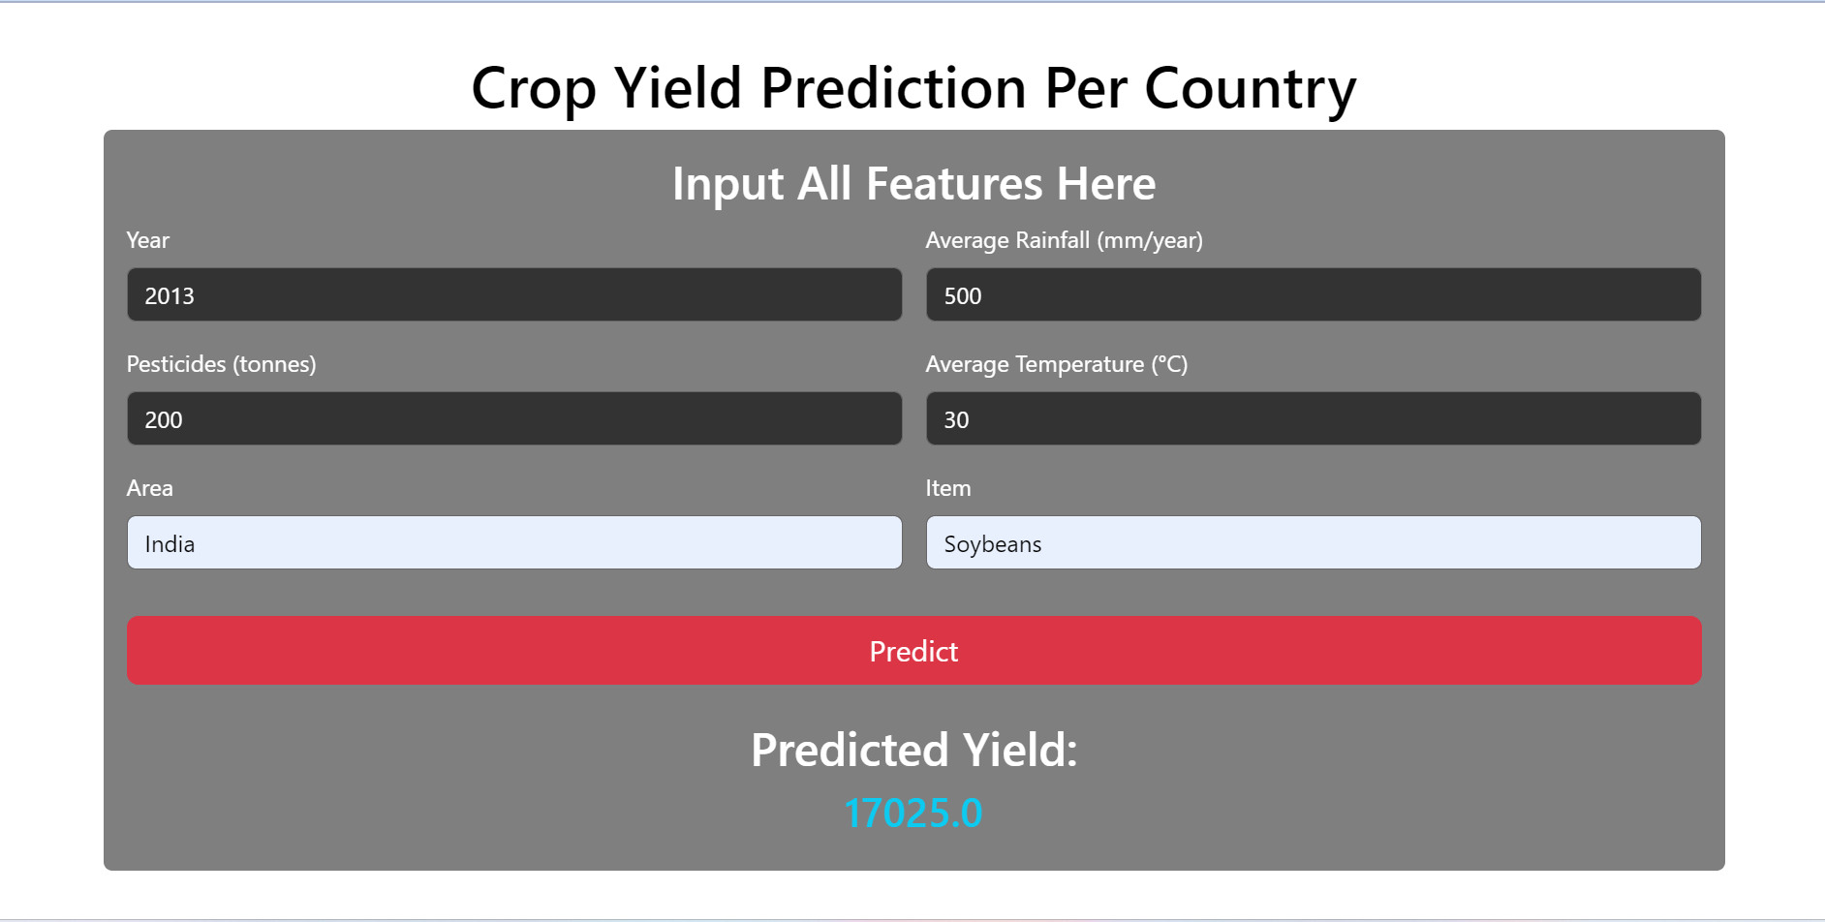

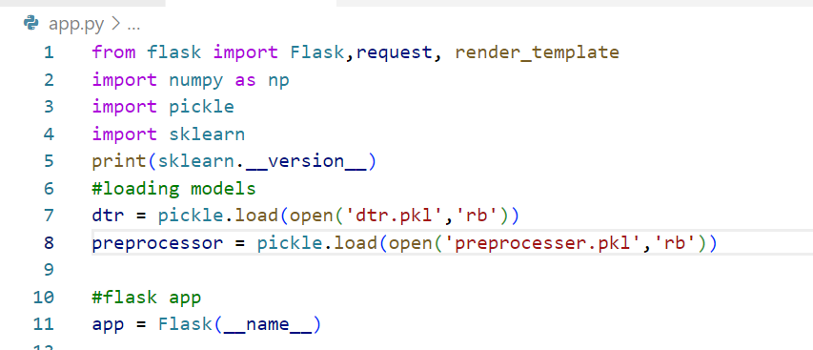

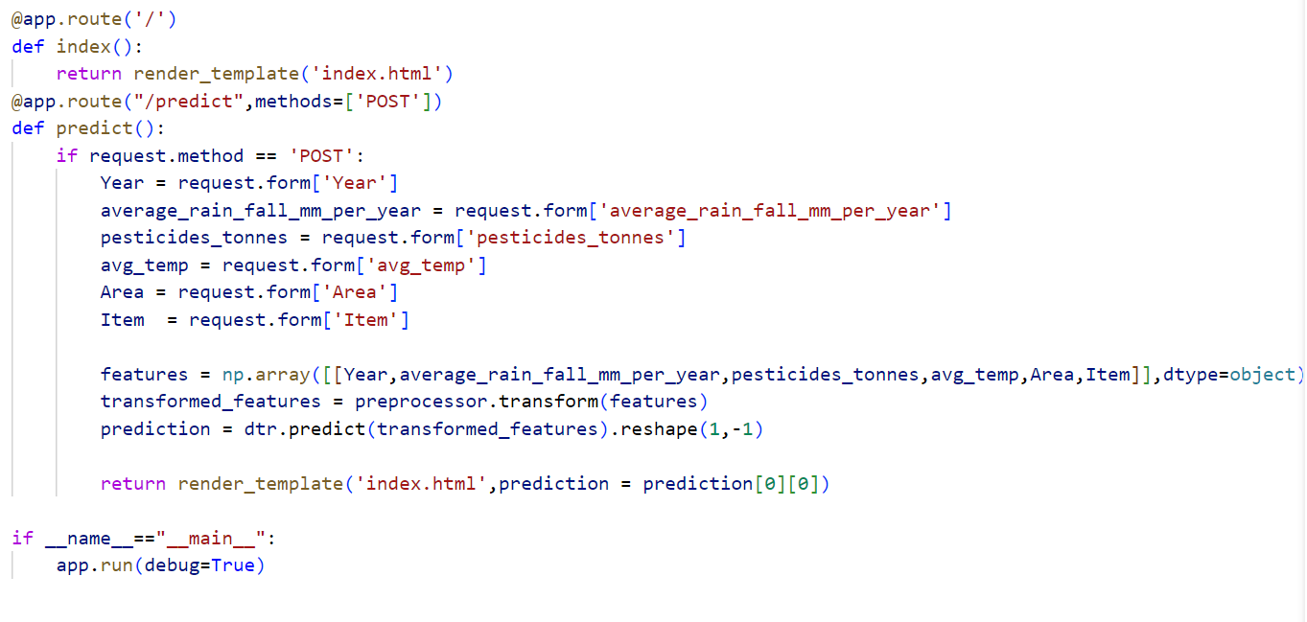

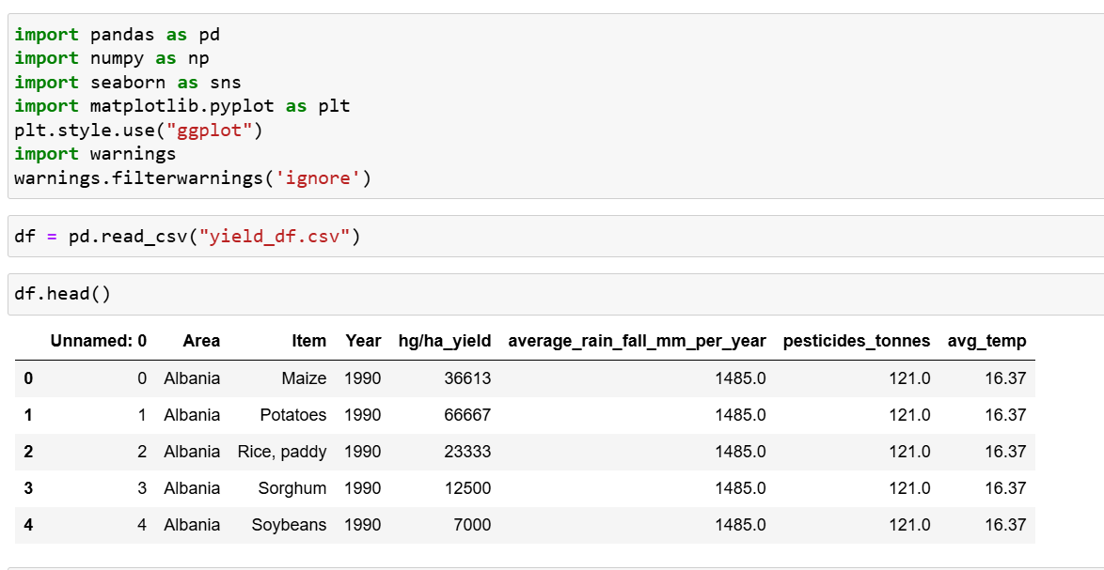

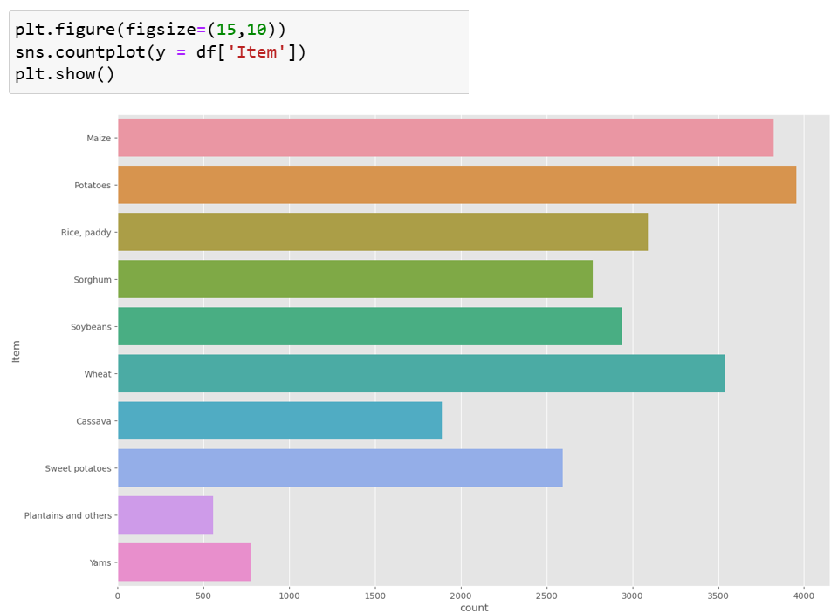

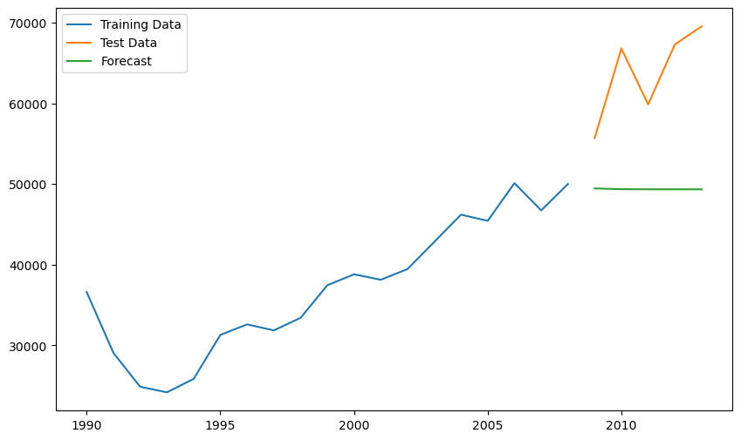

Github link : <https://github.com/rutujat04/Crop-Yield-Prediction>

**13. References**

[1]https://www.researchgate.net/publication/357622040_CROP_YIELD_PREDICTION_BASED_ON_INDIAN_AGRICULTURE_USING_MACHINE_LEARNING

[2] https://www.sciencedirect.com/science/article/pii/S0168169920302301

[3]https://www.researchgate.net/publication/351116727_A_Comprehensive_Review_of_Crop_Yield_Prediction_Using_Machine_Learning_Approaches_With_Special_Emphasis_on_Palm_Oil_Yield_Prediction

[4] https://ieeexplore.ieee.org/stamp/stamp.jsp?arnumber=9410627

[5] https://ieeexplore.ieee.org/document/9432236